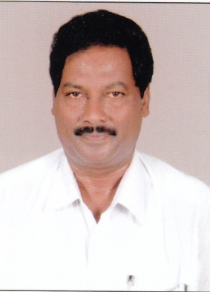
Name: Ch.Ranga Rao

Department : P.G.Department of Social Wrok

Designation: Lecturer

Qualifications: M.A (Social Work), M.L.,(Ph.D)

Total Experience :
Phone No :
Email Id :

Areas of Interest: Criminal / Correctional Administration

Positions Held:
Position | College/University/Organization
Member | NSS Programme Officer , PG Courses Unit, DNR College  Vice President, Indian Association of Lawyers  Legal Advisor, Trade Unions in West Godavari District  Former Vice President, All India Student Federation  Former Vice President, All India Youth Federation

Research Papers Presented in Seminars:
International Level | National Level | State Level | Total
0 | 1 | -- | 1

No. of Seminars / Workshops organized National level : 1
State level : 1

No. of Seminars / Workshops attended National Level : 10
State level : 2

